1. What is a Graph?
A graph is a mathematical structure used to model pairwise relationships between objects. It consists of a set of vertices (or nodes) and a set of edges (or lines) that connect pairs of vertices. Graphs can represent any system in which there is a relationship between pairs of objects, such as roads connecting cities, people connected by friendship, or devices linked in a computer network.

Key Points:
- A graph is defined as G = (V, E) where
  - V = set of vertices
  - E = set of edges
- Vertices represent objects; edges represent relationships between them.
- Graphs can be:
  - Undirected: edges have no direction (e.g., friendships).
  - Directed: edges have direction (e.g., one-way roads).
  - Weighted: edges carry values (e.g., distances).

2. Applications of Graphs
Graphs are used in a wide variety of real-life applications because they can effectively represent complex relationships and interactions.

Key Applications:
- Computer Networks: Vertices = devices, Edges = connections between devices. In computer networks, graphs help model routers and switches connected by cables, allowing algorithms to determine the shortest or most efficient paths for data transmission
- Social Networks: Vertices = users, Edges = friendships or follow links. In social networks, people are represented as nodes, and relationships (like friends or followers) as edges, making it possible to suggest friends or analyze influence.
- Google Maps/GPS: Vertices = locations, Edges = roads (weighted by distance/time). navigation systems like Google Maps use graphs to represent cities and roads, helping users find the fastest or shortest route.
- Project Management: Tasks as nodes, dependencies as edges (used in PERT/CPM)
- Biology/Chemistry: Molecules or proteins modeled as graphs
- Airline Routes: Airports as nodes, flights as edges
- Electrical Circuits: Components as vertices, connections as edges
- Artificial Intelligence: Search trees and state spaces represented as graphs
- Database Design: Entity-Relationship Diagrams (ERD) are graph-based

3. Types of Graphs
Graphs can be classified into various types based on their structure and the kind of relationships they represent.

Infinite Graph & Finite Graph
An infinite graph is a graph that has an infinite number of vertices and/or edges. These graphs are mostly theoretical and are not used in practical applications but are studied in mathematics for concept development.
finite graph has a countable number of vertices and edges, which makes it usable in real-world problems like computer networks or transport systems.

Key Points:
- Infinite Graph: Unlimited number of vertices/edges.
- Finite Graph: Countable (fixed) number of vertices and edges.

Simple Graph
A simple graph is a graph where each pair of vertices is connected by at most one edge, and no vertex has an edge to itself (no loops). It is the most basic and commonly used type of graph.

Key Points:
- No loops (self-connections).
- No multiple edges between any pair of vertices.
📌 Diagram:

Multigraph
A multigraph allows more than one edge (called parallel edges) between a pair of vertices. This is useful in modeling systems where multiple relationships or routes exist between two entities.

Key Points:
- Allows multiple edges between the same vertices.
- No loops (usually).
📌 Diagram:

Pseudograph
A pseudograph is a graph that allows both multiple edges and loops (edges from a vertex to itself). It is a more general form of graph.

Key Points:
- Allows loops (edge from vertex to itself).
- Allows multiple edges.
📌 Diagram:

Directed Graph (Digraph)
A directed graph, or digraph, is a graph where each edge has a direction. That means each connection is one-way, represented by an arrow.

Key Points:
- Edges are one-way (directed).
- Useful in modeling flows, hierarchy, etc.
📌 Diagram:

Simple Directed Graph
A simple directed graph is a directed graph with no loops and no multiple directed edges between the same two vertices. Each edge points from one vertex to another without duplication.

Key Points:
- Directed edges.
- No loops or repeated edges.
📌 Diagram:

Directed Multigraph
A directed multigraph allows multiple directed edges between the same pair of vertices. It can also include self-loops.

Key Points:
- Directed edges.
- Multiple edges in same or opposite directions allowed.
- Can include loops.
📌 Diagram:

Mixed Graph
A mixed graph has both directed and undirected edges. It is used in cases where some relationships are mutual and others are one-way.

Key Points:
- Contains both directed and undirected edges.
- Models systems with different types of relations.
📌 Diagram:

Influence Graph
An influence graph is a type of directed graph used in modeling situations where certain elements (like people, variables, or nodes) influence others. Arrows represent the direction of influence.

Key Points:
- Used in decision making and AI.
- Vertices represent agents or factors.
- Directed edges represent influence.
📌 Diagram (simplified):

Collaboration Graph
A collaboration graph shows connections between individuals or entities based on shared work or participation. It is usually an undirected graph, where two nodes are connected if they worked together on something (like a research paper or project).

Key Points:
- Undirected graph.
- Nodes are people or groups.
- Edge means they collaborated on a task.
📌 Diagram (example: authors):

4. Call Graph
A call graph is a directed graph that represents the calling relationships between different functions or methods in a computer program. In this graph, each node represents a function, and each directed edge (or arrow) from one node to another indicates that the first function calls the second function. This type of graph is commonly used in program analysis, debugging, compiler design, and software engineering. Call graphs can be either static (based on source code analysis) or dynamic (based on runtime behavior). A static call graph might overestimate the possible function calls (showing some that may never occur), whereas a dynamic call graph is based only on the actual function calls that occurred during execution.

Key Points:
- Nodes represent functions or methods.
- Directed edges represent function calls.
- Used in program analysis, debugging, and compiler optimization.
- Can be static (code-based) or dynamic (runtime-based).
- Helps in understanding program structure and function dependencies.
📌 Diagram (Example):
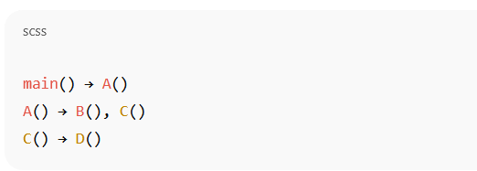

5. Citation Graph, Trivial Graph, and Null Graph
A citation graph is a directed graph used to represent relationships between documents, papers, or authors based on citations. Each node in a citation graph represents a publication, and a directed edge from node A to node B means that paper A cited paper B. This kind of graph is very useful in bibliometric analysis, measuring research impact, identifying key works, and mapping the growth of scientific fields.
A trivial graph is the simplest possible graph that contains only one vertex and no edges. It is called “trivial” because it doesn’t show any relationship — it's just a single point with no connection.
A null graph is a graph that contains ‘n’ vertices but no edges at all. It means none of the vertices are connected to each other. It’s useful in theoretical discussions where no relationship exists between any two elements.

Key Points:
- Citation Graph:
  - Directed graph.
  - Nodes = documents or papers.
  - Edge from A to B means A cites B.
- Trivial Graph:
  - Only one vertex, no edge.
  - Represents an isolated point.
- Null Graph:
  - Multiple vertices, but no edges.
  - No relationship between any pair of vertices.
📌 Simple Diagrams:
- Citation Graph:
Paper A → Paper B → Paper C
- Trivial Graph:
Single dot (node) with no edges.
- Null Graph (for 3 vertices):
A B C (no lines between them)

6. What is Cycle and Wheel in Graph?
A cycle in a graph is a closed path where the starting and ending vertex are the same, and no edge or vertex is repeated (except for the starting/ending point). It requires at least three vertices. In other words, it’s a path that forms a loop. Cycles are important for detecting loops in networks or determining graph properties such as being acyclic or not.
A wheel graph is a special type of graph that looks like a wheel. It is formed by connecting a single central vertex to all vertices of a cycle graph. So, it consists of a cycle (like a rim) and one extra vertex (the hub) that is connected to all others, just like the spokes of a bicycle wheel.

Key Points:
- Cycle:
  - A closed path.
  - Minimum 3 vertices.
  - Start and end at the same node without repeating edges.
- Wheel Graph:
  - A central node connected to all nodes of a cycle.
  - Looks like a bicycle wheel.
  - Notation: Wₙ, where n = total number of vertices.
📌 Diagrams:
- Cycle Graph (C₄):
A — B
| |
D — C
- Wheel Graph (W₅):
Center node connected to a cycle of 4 nodes around it.

7. What is Degree of a Vertex?
In graph theory, the degree of a vertex refers to the number of edges that are connected to it. In undirected graphs, the degree of a vertex is the total number of edges incident to that vertex. For directed graphs, there are two types of degrees: in-degree (number of incoming edges) and out-degree (number of outgoing edges). The degree of a vertex is important because it provides useful information about the vertex’s role in the graph — for instance, whether it is a central, isolated, or peripheral point in the network.

Key Terms with Definitions & Diagrams

🔹 Isolated Vertex
An isolated vertex is a vertex that has no edges connected to it. This means it has a degree of zero and is completely disconnected from the rest of the graph.

Key Points:
- Degree = 0
- No incident edges
- Appears alone or as part of a larger graph
📌 Diagram:
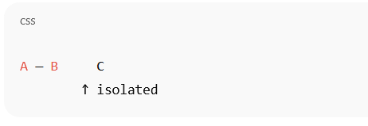

🔹 Pendant Vertex
A pendant vertex is a vertex that is connected to the graph by only one edge. Its degree is exactly one. These are also called leaf nodes in trees.

Key Points:
- Degree = 1
- Connected to only one other vertex
📌 Diagram:

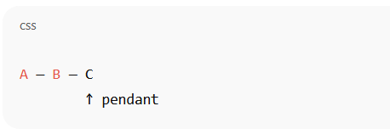

🔹 Neighborhood of a Vertex
The neighborhood of a vertex includes all the vertices that are directly connected to it by an edge. In simple terms, it is the set of all “adjacent” vertices.

Key Points:
- Set of all adjacent vertices
- Denoted as N(v) for a vertex v
📌 Diagram (for vertex B):

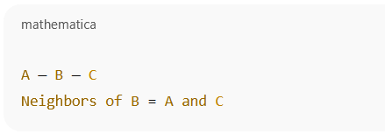

🔹 Regular Graph
A regular graph is a graph in which every vertex has the same degree. That is, each vertex is connected to the same number of edges. If every vertex has degree k, the graph is called a k-regular graph. For example, in a 3-regular graph, each vertex is connected to exactly 3 other vertices.

Key Points:
- All vertices have equal degree
- A k-regular graph has degree = k for all vertices
- Can be cyclic or connected in various ways
📌 Diagram (3-regular graph):

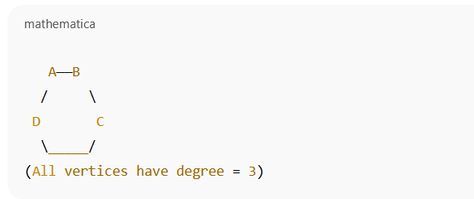

8. Bipartite Graph and Complete Bipartite Graph
A bipartite graph is a special type of graph where the set of vertices can be divided into two disjoint subsets, such that every edge connects a vertex from one subset to a vertex in the other subset. In other words, no two vertices within the same subset are connected. This type of graph is widely used in real-world applications such as job assignments, matchmaking, and social networks where two distinct types of entities interact.
A complete bipartite graph is a bipartite graph where every vertex from one subset is connected to every vertex in the other subset. It is denoted as K<sub>m,n</sub>, where m and n represent the number of vertices in each subset. These graphs contain the maximum possible number of edges for given partitions.

Key Points:
- Bipartite Graph:
  - Vertices can be split into two disjoint sets.
  - Edges exist only between vertices from different sets.
  - No edge connects two vertices within the same set.
- Complete Bipartite Graph:
  - Every vertex in one set is connected to all vertices in the other set.
  - Denoted as K<sub>m,n</sub>, where:
    - m = number of vertices in Set 1
    - n = number of vertices in Set 2
  - Total number of edges = m × n

📌 Diagrams:
Bipartite Graph:

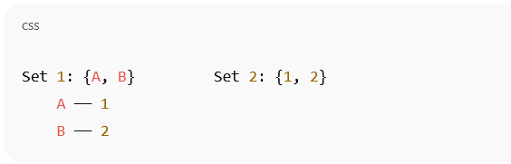

Complete Bipartite Graph K<sub>2,3</sub>:

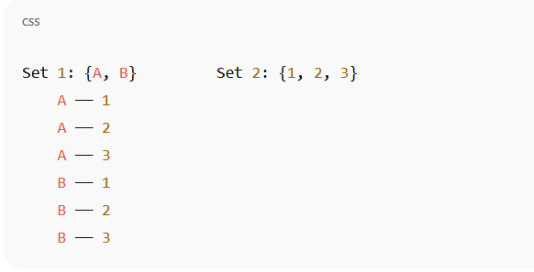

9. Floyd’s Algorithm
Floyd’s Algorithm, is an algorithm used to find the shortest paths between all pairs of vertices in a weighted graph. It works even if the graph contains negative edge weights, as long as there are no negative cycles. The algorithm uses dynamic programming to compare all possible paths through the graph and then gradually builds up the shortest paths between every pair of vertices.
The algorithm initializes a distance matrix with the direct distances between vertices. If no direct edge exists between two vertices, the distance is set to infinity. Then, for each vertex k used as an intermediate vertex, the algorithm checks if going through k offers a shorter path from i to j than the currently known path. This process is repeated for all combinations of vertices, resulting in the shortest paths between all pairs.

Key Points:
- Used for all-pairs shortest paths in a weighted graph.
- Works with negative weights but not with negative cycles.
- Uses dynamic programming to iteratively improve shortest paths.
- Time complexity: O(n³), where n is the number of vertices.
- Produces a distance matrix showing shortest distances between every pair of vertices.

📌 Basic Working Principle (Step Example):
Given a graph with vertices A, B, C, and a weight matrix:

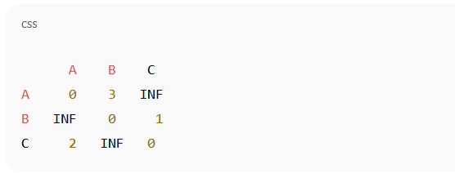
• Initially, distances are directly from the matrix.
• Using vertex A, B, and C as intermediate nodes one by one, update the shortest paths.
• Final matrix gives shortest paths between every pair.

10. Euler's Formula
For any connected planar graph, Euler’s Formula is:
V−E+F=2V - E + F = 2
Where:
- V = Number of vertices
- E = Number of edges
- F = Number of faces (regions including the outer region)
This formula helps us analyze the structure of a planar graph. It works only for graphs that can be drawn without any edges crossing and are connected.
Example:
- A triangle (3 vertices, 3 edges) has 2 faces: one inside and one outside.
V=3,E=3,F=2⇒3−3+2=2V = 3, E = 3, F = 2 \Rightarrow 3 - 3 + 2 = 2
Applications of Euler's Formula:
- In computer graphics and geometry (to check consistency of 3D models)
- For designing printed circuit boards (to avoid wire overlaps)
- In topology and surface modeling
- In map coloring problems

11. Planar Graph
A planar graph is a graph that can be drawn on a flat surface (like a paper or plane) in such a way that no edges cross each other, except at the vertices where they meet. In other words, a planar graph is one that can be represented without any two edges overlapping or intersecting anywhere other than their endpoints. Not all graphs are planar — some complex graphs cannot be drawn without edges crossing.
For a graph to be planar, it must satisfy Euler’s Formula for connected planar graphs:
👉 V − E + F = 2,
Where:
- V = number of vertices
- E = number of edges
- F = number of faces or regions formed by the drawing (including the outer region)
Planar graphs are especially important in fields like circuit design, geography, and computer graphics, where minimizing crossing helps reduce complexity.

Key Points:
- A graph is planar if it can be drawn without edge crossings.
- Only intersections at vertices are allowed.
- Follows Euler’s formula: V − E + F = 2.
- Helps in visual clarity and reducing design complexity.

📌 Diagram:
Here are two versions of the same graph — one that appears non-planar but is actually planar:

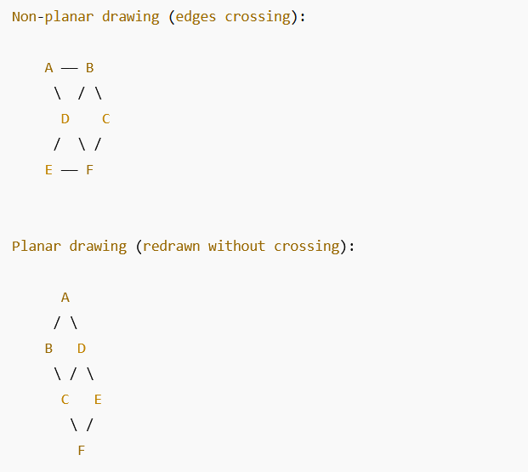

Applications of Planar Graphs
Planar graphs have various practical uses in real-world scenarios where minimizing overlapping or intersection is crucial. In electrical circuit design (VLSI), planar graphs help in arranging circuit elements on a chip without crossing wires, which can reduce signal interference. In geographic mapping, regions (like countries or cities) are modeled as planar graphs where edges (borders or roads) shouldn’t overlap unnecessarily. In network layout problems, such as designing pipelines, road maps, or underground cable systems, planar graphs help simplify layout design. They are also important in graph drawing algorithms, computer graphics, and game design, where clear visual representation is necessary.

Application Highlights:
- VLSI (Very-Large-Scale Integration) circuit layout
- Geographical map coloring (like four-color theorem)
- Road, subway, or cable network design
- Computer graphics and UI design
- Game board modeling
- Face/region detection in geometry

12. Handshaking Theorem
The Handshaking Theorem states:
∑degree of all vertices=2×number of edges\sum \text{degree of all vertices} = 2 \times \text{number of edges}
This means if you add the degrees (number of edges connected) of all vertices in an undirected graph, you will get twice the number of edges. That’s because every edge connects two vertices.
Example:
In a triangle (3 vertices, 3 edges), each vertex has degree 2.
2+2+2=6=2×32 + 2 + 2 = 6 = 2 \times 3
Important Result:
- The number of vertices with an odd degree is always even.
Applications:
- Used in network analysis
- Helps detect anomalies in social or communication networks
- Fundamental to proofs in Eulerian paths and cycles

13. Connected Graph and Disconnected Graph
A connected graph is a type of graph in which there is a path between every pair of vertices. In other words, starting from any vertex, you can reach any other vertex in the graph by following the edges. This means the graph is all in one piece — no isolated sections. In the case of a directed graph, it is considered strongly connected if there's a directed path from any vertex to every other vertex.
On the other hand, a disconnected graph is a graph in which at least one pair of vertices is not connected by any path. The graph consists of two or more separate components (subgraphs) that are not linked by any edges.

Key Points:
- Connected Graph:
  - A path exists between every pair of vertices.
  - Appears as one complete piece.
  - In a directed graph, strong connectivity means every vertex can reach every other.
- Disconnected Graph:
  - One or more vertices (or sets of vertices) are not connected.
  - Graph has separate components.
📌 Diagrams:
Connected Graph:

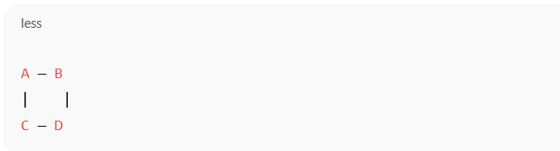

Disconnected Graph:

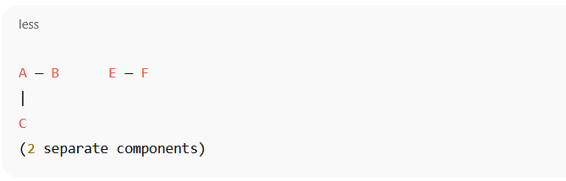

14. Adjacency Matrix
An adjacency matrix is a way to represent a graph using a 2D array (matrix). If a graph has n vertices, then the matrix is of size n × n. Each row and column corresponds to a vertex, and the entry at position (i, j) is:
- 1 if there is an edge from vertex i to j
- 0 if there is no edge
In undirected graphs, the adjacency matrix is symmetric because if A is connected to B, then B is also connected to A. In directed graphs, the matrix may not be symmetric.
This representation is useful in computer algorithms because it allows for fast edge lookup but uses more memory, especially for sparse graphs.

Key Points:
- Size of matrix = n × n where n = number of vertices.
- 1 = edge exists, 0 = no edge.
- Symmetric in undirected graphs.
- Fast for edge lookup.
- Memory intensive for large sparse graphs.
📌 Example:
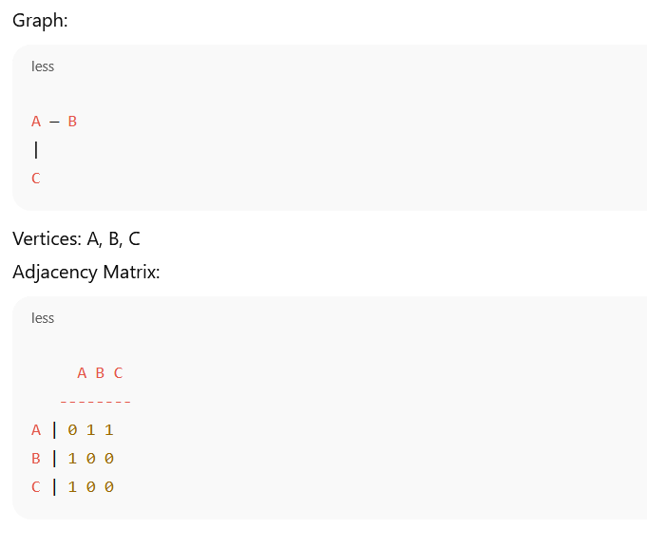

15. Incidence Matrix
An incidence matrix is another way to represent a graph using a matrix format. In this case, if the graph has n vertices and m edges, then the matrix is of size n × m. Each row represents a vertex, and each column represents an edge.
For undirected graphs, if an edge e is incident (connected) to vertex v, then the entry is 1. If it is not, the entry is 0.
For directed graphs, it is usually written as:
- -1 if the edge leaves the vertex.
- +1 if the edge enters the vertex.
- 0 if the vertex is not part of that edge.
This matrix is useful for network flow analysis, electrical circuit modeling, and other applications.

Key Points:
- Size of matrix = n × m (n = vertices, m = edges).
- Undirected: 1 if the vertex is incident to the edge.
- Directed:
  - -1 if the vertex is the edge’s start.
  - +1 if the vertex is the edge’s end.
  - 0 otherwise.
- Good for analyzing edge-vertex relationships.
📌 Example:
Graph:

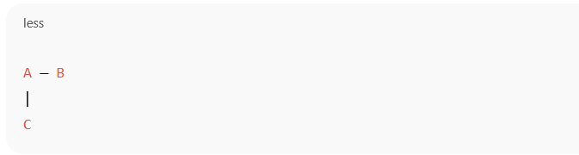
Let:
- Edge e1: A—B
- Edge e2: A—C
Vertices: A, B, C
Edges: e1, e2
Incidence Matrix:
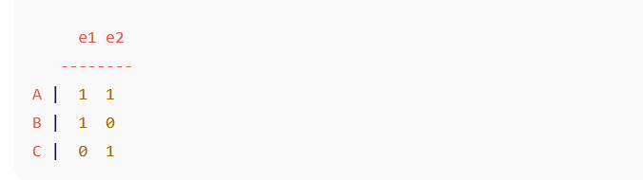

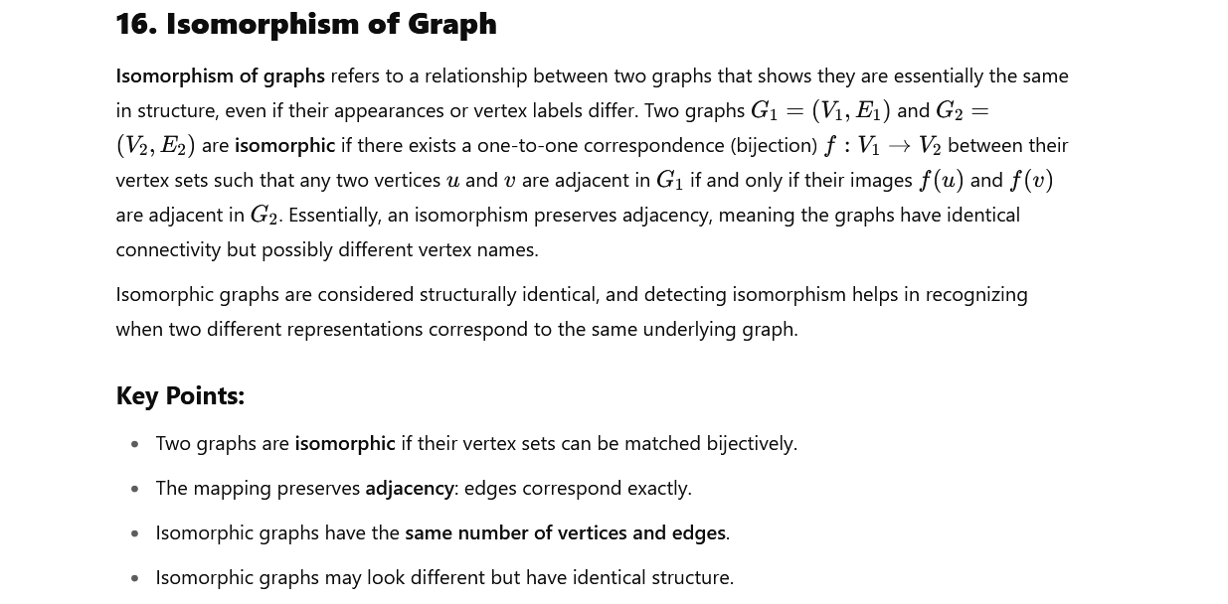

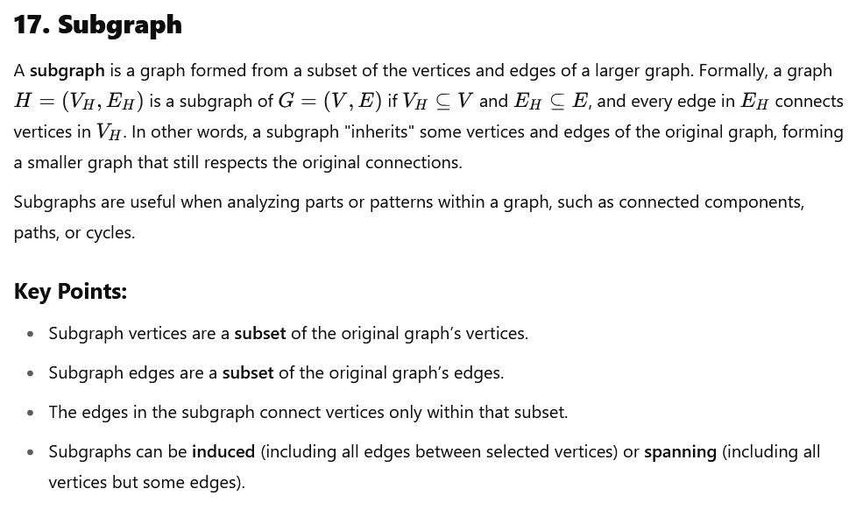

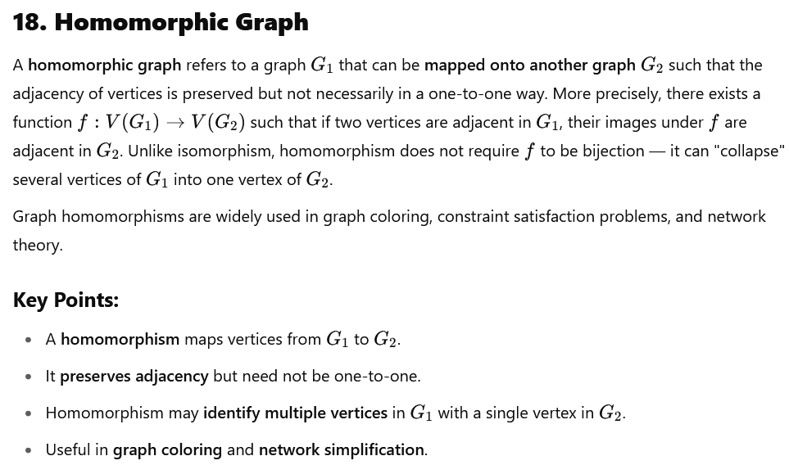

19. Define Bi-Partial Graph
A bi-partial graph is a type of graph that is closely related to bipartite graphs but with a slight difference: it is a graph whose vertex set can be divided into two disjoint subsets such that each subset induces a partial graph (a subgraph that may not be complete), and edges exist only between the two subsets, not within them. Essentially, it generalizes the idea of bipartite graphs by allowing more complex internal structure within each subset, but still no edges within the same subset.
This concept is used to model systems where entities are divided into two groups with interactions only occurring between groups, but each group may have its own internal partial structures.

Key Points:
- Vertex set split into two disjoint subsets.
- Edges connect only vertices from different subsets.
- Each subset induces a partial graph (not necessarily complete).
- Generalizes bipartite graphs by allowing internal partial structures within subsets

20. Euler's Formula for Planar Graph
This is the same formula as given earlier in Question 10:
V−E+F=2V - E + F = 2
Used for connected planar graphs to relate the number of vertices, edges, and faces. It is useful in graph drawing, modeling 3D surfaces, and solving problems related to planar embeddings.

21.Hamiltonian Graph
A Hamiltonian Graph contains a Hamiltonian cycle, which is a path that visits every vertex exactly once and returns to the starting vertex.
Difference from Eulerian Path:
- Hamiltonian path visits each vertex once.
- Eulerian path uses each edge once.
Applications:
- Route planning (e.g., travelling salesman problem)
- Scheduling and organizing events
- DNA sequencing in bioinformatics
Example:
In a pentagon, if you start from one vertex and visit all others once in a circular manner and return to the start, that forms a Hamiltonian cycle.

22. Define Tree, Spanning Tree, Minimum Spanning Tree
A tree is a special type of graph that is connected and contains no cycles. In other words, it is a graph where there is exactly one path between any two vertices, making it acyclic and connected. Trees are important in computer science and mathematics because they represent hierarchical structures like file systems, organizational charts, and decision processes.
A spanning tree of a graph is a subgraph that includes all the vertices of the original graph and is itself a tree. This means the spanning tree connects every vertex without creating any cycles, but only with a subset of the original edges. Every connected graph has at least one spanning tree, and often multiple spanning trees.
A minimum spanning tree (MST) is a spanning tree where the sum of the weights of its edges is as small as possible. It applies only to weighted graphs, where each edge has a numerical value (like cost or distance). Finding the MST is important in network design, such as minimizing the cost of wiring or road construction while keeping all nodes connected.

Key Points:
- Tree:
  - Connected and acyclic graph.
  - Exactly one path between every pair of vertices.
- Spanning Tree:
  - A subgraph that includes all vertices of the original graph.
  - Connected and acyclic.
  - Contains minimum edges to keep the graph connected.
- Minimum Spanning Tree (MST):
  - A spanning tree with the minimum total edge weight.
  - Useful for optimizing cost in networks.
  - Algorithms to find MST: Prim’s, Kruskal’s.

23. Define Labeled and Weighted Graph
A labeled graph is a graph where each vertex and/or edge is assigned a unique identifier or label. These labels help distinguish vertices and edges from each other, which is especially useful when vertices represent specific entities (like cities, people, or network devices) or when edges carry special meanings. The labels can be numbers, letters, or any symbols, and they make it easier to refer to specific parts of the graph in discussions or computations.
A weighted graph is a graph in which each edge has an associated numerical value called a weight. These weights represent quantities such as distances, costs, capacities, or any measure that quantifies the relationship between the vertices connected by that edge. Weighted graphs are important in optimization problems like shortest path, minimum spanning tree, and network flow.

Key Points:
- Labeled Graph:
  - Each vertex and/or edge has a unique label or identifier.
  - Labels help in identification and referencing.
  - Useful in mapping real-world entities.
- Weighted Graph:
  - Each edge has a numerical weight/value.
  - Weights represent costs, distances, or capacities.
  - Essential in optimization and path-finding problems.

24. Define Complete Sum of Products
In digital logic and Boolean algebra, a Complete Sum of Products (SOP) expression is a Boolean expression formed by the OR (sum) of all possible AND (product) terms that cover every combination of variables for which the function outputs 1. Each product term in the SOP form is called a minterm, and it includes all variables in either true or complemented form.
The "complete" part means that the SOP expression contains all minterms corresponding exactly to the input combinations where the function is true, with no missing terms. This form is canonical and guarantees a unique representation of a Boolean function, which is very useful for simplification, analysis, and implementation in digital circuits.

Key Points:
- Sum of Products (SOP): OR of AND terms.
- Complete SOP includes all minterms for which the function outputs 1.
- Each minterm contains all variables in true or complemented form.
- Provides a unique, canonical form of the Boolean function.
- Used in digital logic design and simplification.

